 

### MINOR PROJECT REPORT

### On

SMART CAR PARKING

### Submitted by

**MOKISH J (927622BEE071)**

**SURENDAR CR (927622BEE119) VIGNESH P (927622BEE125)**



**DEPARTMENT OF ELECTRICAL AND ELECTRONICS ENGINEERING M.KUMARASAMY COLLEGE OF ENGINEERING**

(An Autonomous Institution Affiliated to Anna University, Chennai) THALAVAPALAYAM, KARUR-639113.

### MAY 2024

**M.KUMARASAMY COLLEGE OF ENGINEERING**

(Autonomous Institution, Affiliated to Anna University, Chennai)

## BONAFIDE CERTIFICATE

Certified that this Report titled **“SMART CAR PARKING”** is the bonafide work of **MOKISH J (927622BEE071), SURENDAR CR (927622BEE119), VIGNESH P (927622BEE125)** who

carried out the work **SMART CAR PARKING** during the academic year (2023-2024) under my supervision. Certified further that to the best of my knowledge the work reported here in does not form part of any other project report.

**SIGNATURE SIGNATURE**

**SUPERVISOR HEAD OF THE DEPARTMENT**

Dr S Banumathi M.E., Ph.D., Dr J Uma M.E., Ph.D.,

Professor Professor & Head

Department of Electrical Department of Electrical

and Electronics Engineering and Electronics Engineering

M.Kumarasamy College of M.Kumarasamy College of

Engineering, Karur Engineering, Karur

Submitted for Minor Project II (18EEP202L) viva-voce Examination held at M.Kumarasamy College of Engineering, Karur-639113 on………………..

ii

### DECLARATION

We affirm that the Minor Project report titled “**SMART CAR PARKING ”** being submitted in partial fulfillment for the award of **Bachelor of Engineering in Electrical and Electronics Engineering** is the original work carried out by us.

|  |  |  |
| --- | --- | --- |
| **REG.NO** | **STUDENT NAME** | **SIGNATURE** |
| **927622BEE071** | **MOKISH J** | **------------------------** |
| **927622BEE119** | **SURENDAR CR** | **------------------------** |
| **927622BEE125** | **VIGNESH P** | **------------------------** |

iii

**VISION**

**VISION AND MISSION OF THE INSTITUTION**

* To emerge as a leader among the top institutions in the field of technical education.

**MISSION**

* Produce smart technocrats with empirical knowledge who can surmount the global Challenges.
* Create a diverse, fully-engaged, learner-centric campus environment to provide Quality education to the students.
* Maintain mutually beneficial partnerships with our alumni, industry and Professional associations.

**DEPARTMENT OF ELECTRICAL AND ELECTRONICS ENGINEERING VISION**

To produce smart and dynamic professionals with profound theoretical and practical knowledge comparable with the best in the field.

**MISSION**

* Produce Hi-tech professionals in the field of Electrical and Electronics Engineering by inculcating core knowledge.
* Produce highly competent professionals with thrust on research.
* Provide personalized training to the students for enriching their skills.

#### PROGRAMME EDUCATIONAL OBJECTIVES (PEOs)

* **PEO1:** Graduates will have flourishing career in the core areas of Electrical Engineering and also allied disciplines.
* **PEO2:** Graduates will pursue higher studies and succeed in-academic/research careers
* **PEO3:** Graduates will be a successful entrepreneur in creating jobs related to Electrical and Electronics Engineering /allied disciplines.
* **PEO4:** Graduates will practice ethics and have habit of continuous learning for their success in the chosen career.

**PROGRAMME OUT COMES (POs)**

After the successful completion of the B.E. Electrical and Electronics Engineering degree program, the students will be able to:

**PO1: Engineering Knowledge:** Apply the knowledge of mathematics, science, engineering fundamentals, and an engineering specialization to the solution of complex engineering problems.

**PO2: Problem Analysis:** Identify, formulate, review research literature, and analyze complex engineering problems reaching substantiated conclusions using first principles of mathematics, natural sciences, and engineering sciences.

**PO3: Design/Development of solutions:**

Design solutions for Complex engineering problems and design system components or processes that meet the specified needs with appropriate consideration for the public health and safety, and the cultural, societal and environmental considerations.

**PO4: Conduct Investigations of complex problems:** Use research-based knowledge and research methods including design of experiments, analysis and interpretation of data, and synthesis of the information to provide valid conclusions.

**PO5: Modern Tool Usage:** Create, select and apply appropriate techniques, resources and modern engineering and IT tools including prediction and modeling to complex engineering activities with an understanding of the limitations.

**PO6: The Engineer and Society:** Apply reasoning in formed by the contextual knowledge to assess societal, health, safety, legal and cultural issues and the consequent responsibilities relevant to the professional engineering practice.

**PO7: Environment and Sustainability:** Understand the impact of the professional engineering solutions in societal and environmental contexts, and demonstrate the knowledge of, and need for sustainable development.

**PO8: Ethics:** Apply ethical principles and commit to professional ethics and responsibilities and norms of the engineering practice.

**PO9: Individual and Teamwork:** Function effectively as an individual, and as a member or leader in diverse teams, and in multi-disciplinary settings.

**PO10: Communication:** Communicate effectively on complex engineering activities with the engineering community and with society at large, such as being able to comprehend and write effective reports and design documentation, make effective presentations and give and receive clear instructions.

**PO11: Project Management and Finance:** Demonstrate knowledge and understanding of the engineering and management principles and apply these to one’s own work, as a member and leader in a team, to manage projects and in multi-disciplinary environments.

**PO12: Life-long learning:** Recognize the need for, and have the preparation and ability to engage in independent and life-long learning in the broadest context of technological change.

#### PROGRAM SPECIFIC OUT COMES(PSOs)

The following are the Program Specific Outcomes of Engineering Students:

* **PSO1:** Apply the basic concepts of mathematics and science to analyses and design circuits, controls, Electrical machines and drives to solve complex problems.
* **PSO2:** Apply relevant models, resources and emerging tools and techniques to provide solutions to power and energy related issues &challenges.
* **PSO3:** Design, Develop and implement methods and concepts to facilitate solutions for electrical and electronics engineering related real-world problems.

|  |  |
| --- | --- |
| **Abstract(Key Words)** | **Mapping of Pos and PSOs** |
| IR Sensor, servo motor, Arduino, LCD display. | PO1,PO2,PO3,PO4,PO5,PO6,PO7,PO8,PO9,PO10,PO11,PO12,PS01,PSO2, PSO3. |

### [ACKNOWLEDGEMENT](https://www.google.com/search?rlz=1C1CHBD_enIN820IN820&q=ACKNOWLEDGEMENT&spell=1&sa=X&ved=0ahUKEwj99az1_ZXhAhVN63MBHRVODE4QkeECCCkoAA&cshid=1553265789884876)

Our sincere thanks to **Thiru.M.Kumarasamy, Founder** and **Dr.K.Ramakrishnan B.E, Chairman** of **M.Kumarasamy College of Engineering** for providing extra ordinary infrastructure, which helped us to complete the Minor project in time.

It is a great privilege for us to express our gratitude to our esteemed **Principal Dr.B.S.Murugan M.Tech., Ph.D.,** for providing us right ambiance for carrying out the project work.

We would like to thank our **Head of the Department Dr.J.Uma M.E., Ph.D., Department of Electrical and Electronics Engineering,** for her unwavering moral support throughout the evolution of the project.

We would like to express my deep gratitude to our Minor Project Guide **Dr.S.Banumathi ME.,Phd., Professor, Department of Electrical and Electronics Engineering,** for her constant encouragement, kind co-operation, valuable suggestions and support rendered in making our project a success.

We offer our whole hearted thanks to our Minor project coordinator **Dr.B.RAJESH KUMAR M.E.,Ph.D., Assistant Professor., Department of Electrical and Electronics Engineering,** for his constant encouragement ,kind co-operation and valuable suggestions for making our project a success.

We are glad to thank all the **Faculty Members** of **Department of Electrical and Electronics Engineering** for extending a warm helping hand and valuable suggestions throughout the project.

Words are boundless to thank **Our Parents and Friends** for their constant encouragement to complete this Minor project successfully.

**CHAPTER NO**

**1 ABSTRACT** 6

## TABLE OF CONTENTS

### TITLE PAGE NO

### 2 SURVEY FORM ANALYSIS 7

Name and Address of the Community Problem identification

**3 LITERATURE REVIEW** 9

### 4 PROPOSED METHODOLOGY 11

Block Diagram Description Cost Estimation

**5**

**FUTURE SCOPE AND ITS IMPLEMENTATION PLAN**

14

### 6 REFERENCES 16

**ABSTRACT**

In metropolitan cities, vehicle parking has become a major concern in all busy areas and a good traffic system needs a good parking system. Different types of vehicle parking are applied worldwide namely Multi-level Automated Car Parking, Automated Car Parking System, Volkswagen Car Parking, vertical car parking etc. Parallel parking is challenge for all drivers say amateurs or the experts. Sometimes parked cars in the streets creates extra traffic jam and Traffic jam is already a curse in city. One lane of a road gets always blocked Because of parking. In filling stations cars always create a line to be refilled and blocks a lane of the road. Parking is a key component of transportation program. The city has addressed parking problems associated with educational institutes, entertainment users. religious institutes, commercial activities, special events etc.From this method we can Identify whether the car parking slot is empty or not without roaming the parking place it will help by displaying which slot is empty and number of empty slot. The main componentsare IR sensor, VR sensor, Arduino, LCD display, Servo motor. The IR sensor is placed in parking place to sense whether the place is filled or not, if not it will display which slot is empty through LCD display.

# SURVEY VISIT

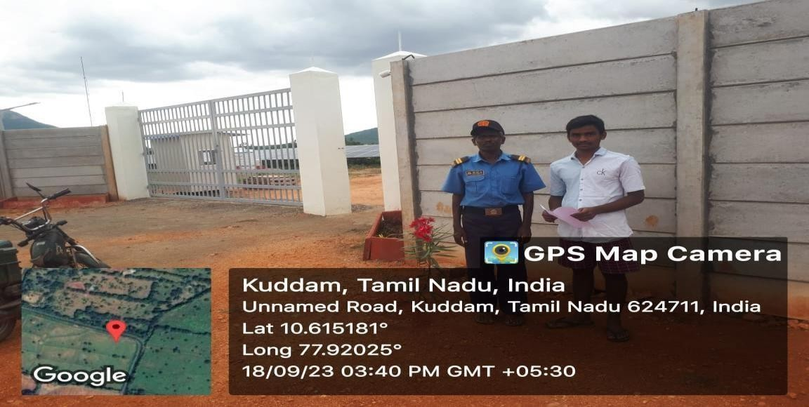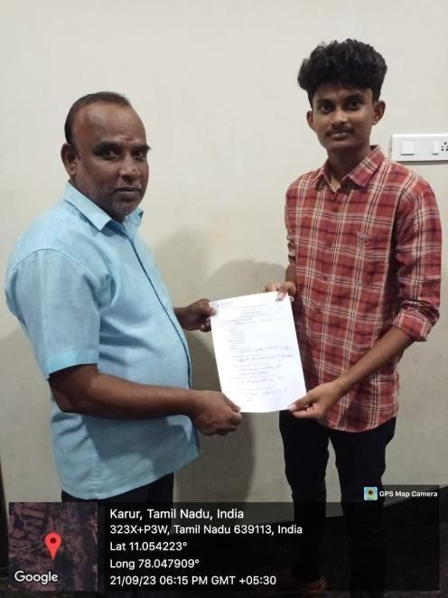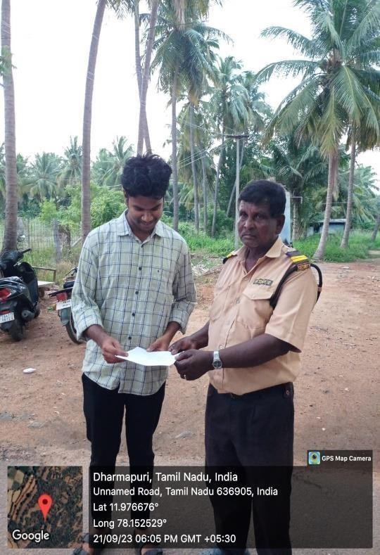

### CHAPTER 1

**SURVEY FORM ANALYSIS**

* 1. **NAME AND ADDRESS OF THE COMMUNITY:**

K Chellamuthu (security) RG Valasu, Dindigul

* 1. **PROBLEM IDENTIFICATION:**
     + Drivers faced difficulties in searching of slots while parking.
     + Securities faced difficulties in searching of empty slots to convey to driver.
     + Traffic congestion due to vision in search for a parking place
     + Traffic congestion leads to fuel wastage pollution
     + Traditional parking system offer require customers to take entry ticket which leads to increase in waiting time.

**SOLUTION:**

IR Sensor 1 is placed in the parking slot to sense wheather the slot is empty

or not.IR Sensor 2 is placed in the entrance gate and servo motor act as entry and exit gate. LCD display is placed in the entrance gate.IR Sensor 1 is sense and display in LCD display number of slot is empty. Servo motor act as open gate if slot is empty.

**CHAPTER 2 LITERATURE REVIEW**

#### Paper 1:

**Title; 1**. "Arduino-Based Smart Parking Systems"

**Author**: Fadi Al-Turjman

**Inference:** Arduino technology in smart car parking systems. Authors highlight how Arduino microcontrollers enhance sensor integration, real-time data processing, and communication protocols to optimize parking space utilization**.**

#### Paper 2:

**Title;** "IoT and Arduino Synergy in Smart Car Parking: A Survey"

**Author:** Shugang Li

**Inference:** This review explores the synergies between the Internet of Things (IoT) and Arduino platforms in smart parking solutions. The surveyed literature underscores how Arduino's versatility facilitates seamless connectivity with IoT devices, contributing to efficient data collection, analysis, and user-friendly parking

#### Paper 3:

**Title;** "Machine Learning Applications in Arduino-Enabled Smart Parking"

**Author:** Mohammad Reza Khorsavi

**Inference:** This literature review investigates the intersection of machine learning algorithms and Arduino technology in smart car parking systems. Authors discuss how Arduino's computational capabilities, when coupled with machine learning, enable predictive parking solutions, improving user experience and resource allocation

#### Paper 4:

**Title;** "Security and Privacy Considerations in Arduino-Based Smart Parking Systems: An In- Depth Analysis.

**Author:** L.Barone

**Inference:** Focusing on the security aspects, this review critically examines literature addressing potential vulnerabilities and privacy concerns in Arduino-driven smart parking infrastructure. It emphasizes the importance of secure communication protocols and data encryption to safeguard user information and system integrity.

#### Paper 5:

**Title;** "Environmental Sustainability in Smart Car Parking: A Literature Synthesis".

**Author:** Azanna Chi

**Inference:** Investigating 0the ecological impact, this review delves into research addressing how smart parking contributes to reduced emissions.It explores the environmental benefits associated with the implementation of smart parking technologies.

**CHAPTER 3 PROPOSED METHODOLOGY**

* 1. **BLOCK DIAGRAM**

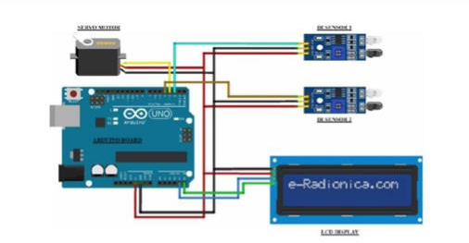

* 1. **DESCRIPTION**

The implementation of this work will help to identify whether the car parking slot is empty or not without roaming the parking place it will help by displaying which slot is empty and number of empty slot. The main components are IR sensor, VR sensor, Arduino, LCD display, Servo motor. The IR sensor is placed in parking place to sense whether the place is filled or not, if not it will display which slot is empty through LCD display. Now place the sensors and servo motor at accurate positions. There are four parking slots in this project, IR sensor-3, 4, 5, and 6 are placed at slot-1, 2, 3, and 4 respectively. IR sensor-1 and 2 are placed at the entry and exit gate respectively and a servo motor is used to operate the common single entry and exit gate. The LCD display is placed near the entry gate. The system used IR sensor-3, 4, 5, and 6 to detect whether the parking slot is empty or not and IR sensor-1, and 2 for detecting vehicles arriving or not at the gate. In the beginning, when all parking slots are empty, then the LCD display shows all slots are empty. When a vehicle arrives at the gate of the parking area then the IR sensor-1 detects the vehicle and the system allowed to enter that vehicle by opening the servo barrier.After entering into the parking area when that vehicle occupies a slot then the LED display shows that the slot is full. In this way, this system automatically allows 4 vehicle. In case the parking is full, the system blocked the entrance gate by closing the servo barrier. And the LED display shows that slot-1, 2, 3, and 4 all are full. When a vehicle leaves a slot and arrives at the gate of the parking area then the IR sensor-2 detects that vehicle and the system open the servo barrier. Then the LED display shows that the slot is empty. Again the system will allow entering a new vehicle.

* 1. **COST ESTIMATION**

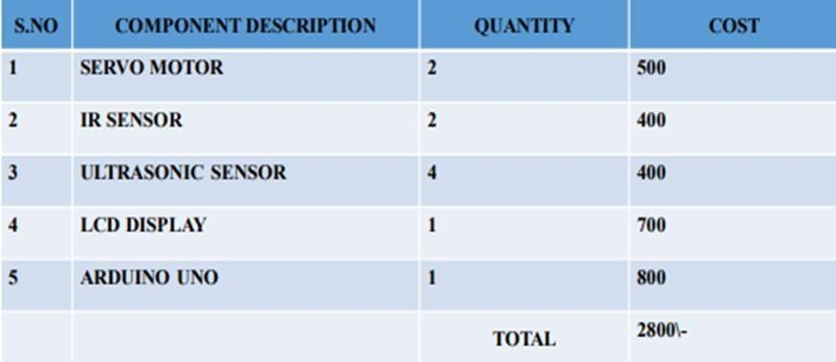

**CHAPTER 4**

**FUTURE SCOPE & ITS IMPLEMENTATION PLAN**

* + - **Enhanced User Experience through Mobile Apps**: Future smart parking applications may focus on further enhancing the user experience. This could involve real-time updates, personalized recommendations, and additional features in mobile apps to make the process of finding and paying for parking even more convenient
    - **Autonomous Vehicles Integration**: As autonomous vehicles become more prevalent, smart parking systems can evolve to seamlessly integrate with these vehicles. This may involve communication protocols to enable autonomous cars to navigate and park efficiently within smart parking facilities
    - **Smart City Integration**: The integration of smart parking into larger smart city initiatives is a promising avenue. Coordination with other urban systems, such as traffic management and public transportation, can lead to more holistic approaches in addressing urban mobility challenges.
    - **System Design and Planning**: Define the goals and objectives of the smart parking system. Conduct a thorough analysis of the parking area, considering the number of spaces,layout, and potential challenges. Determine the technologies to be used, such as sensors, IoT devices, and communication protocols
    - **Maintenance and Updates**: Establish a routine maintenance schedule to ensure the continued functionality of sensors and other components. Implement regular updates toaddress security vulnerabilities and improve system feat

IMPLEMENTATION SNAP SHOT

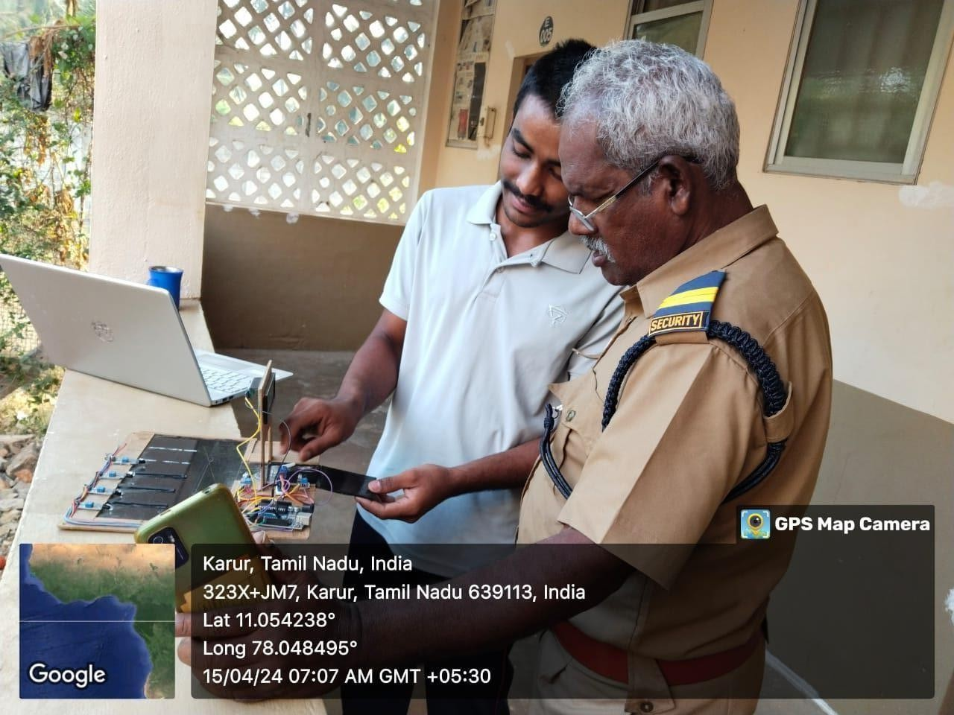

IMPLEMENTATION VIDEO LINK

https://drive.google.com/file/d/1N2DidDTLpw8T5ZvnEr3XrvC- zIwbSV33/view?usp=sharing

# REFERENCES

* + - <https://www.nature.com/articles/s41598-022-10076-4>
    - <https://www.sciencedirect.com/science/article/pii/S2665917422001088>
    - <https://www.sciencedirect.com/science/article/pii/S2405844021011531>
    - <https://www.researchgate.net/publication/345650679_Smart_Car_Parking_System>